|  |  |
| --- | --- |
| **Name :-** | Aryan Dilipbhai Langhanoja |
| **Enroll No: -** | 92200133030 |

## Basic NOT gate and its application in fuel level indicator

* **Aim** :-

To apply the NOT gate logic in an application to indicate that the fuel level in a tank has reached the minimum (reserve) level. The user can compute the output of a given circuit with the help of a generalized simulator. The user will be able to construct, simulate and verify the output of the fuel level application.).

* 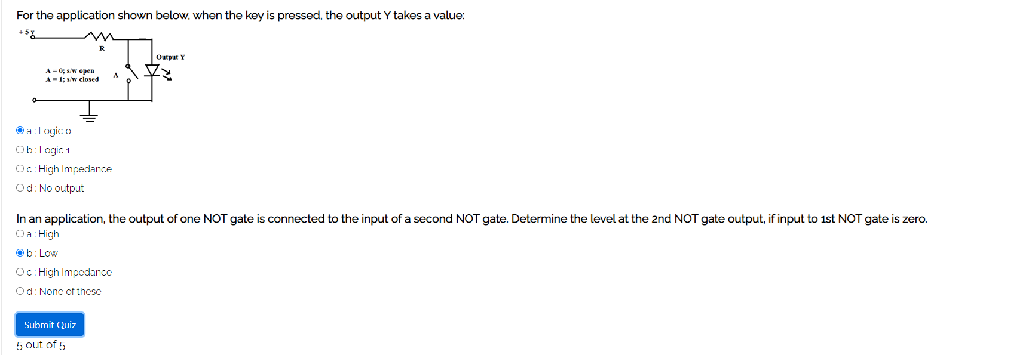**Pre-test :-**

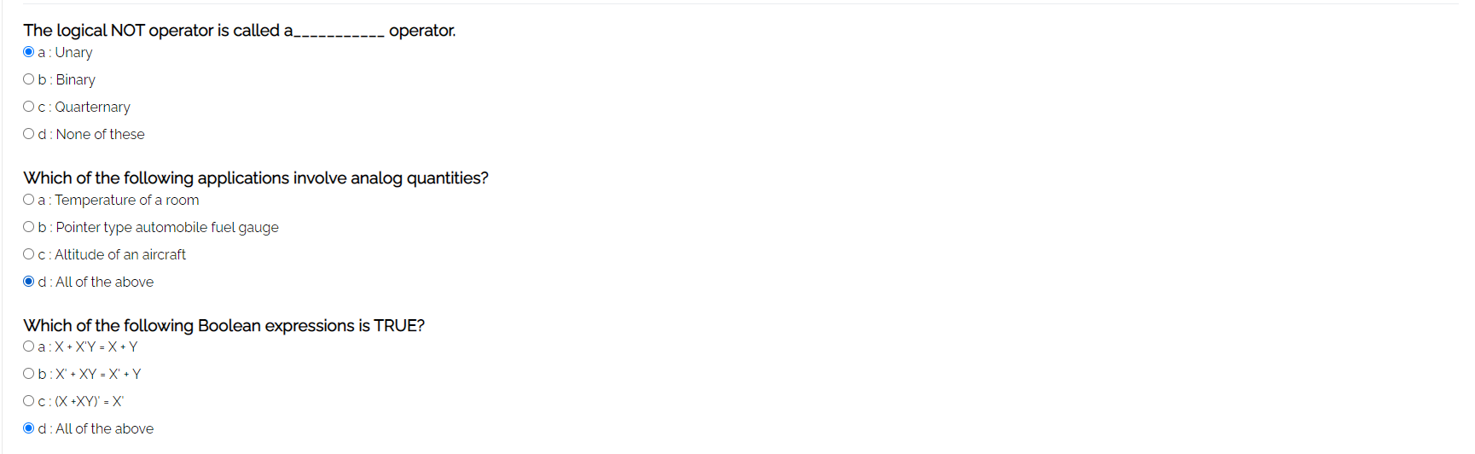

* 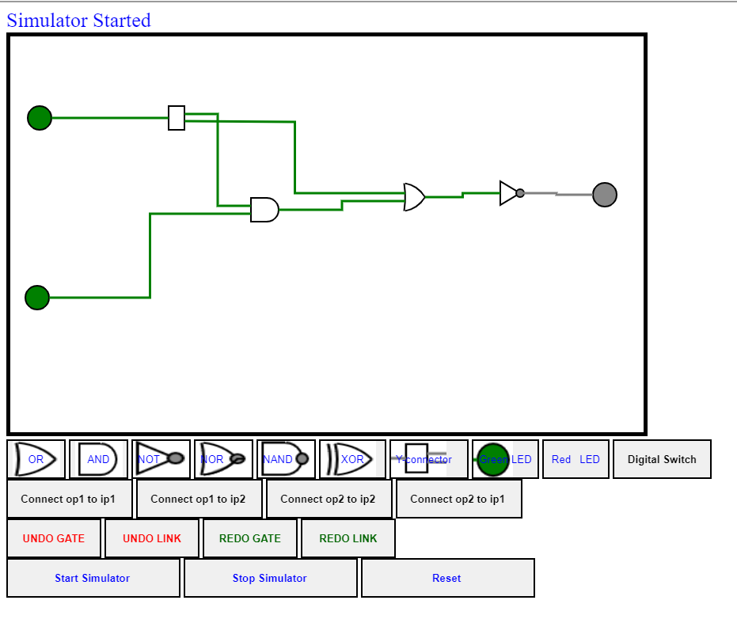**Simulation :-**
* 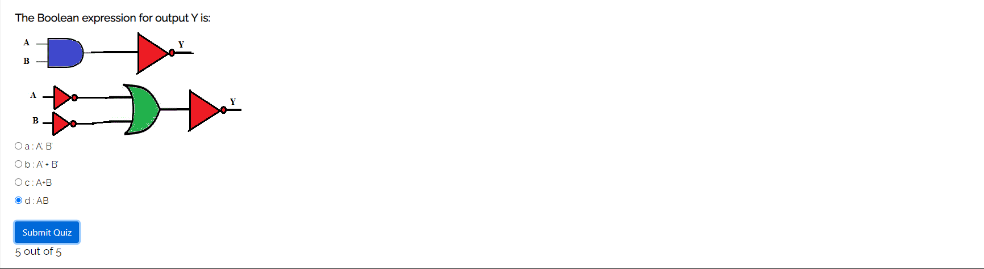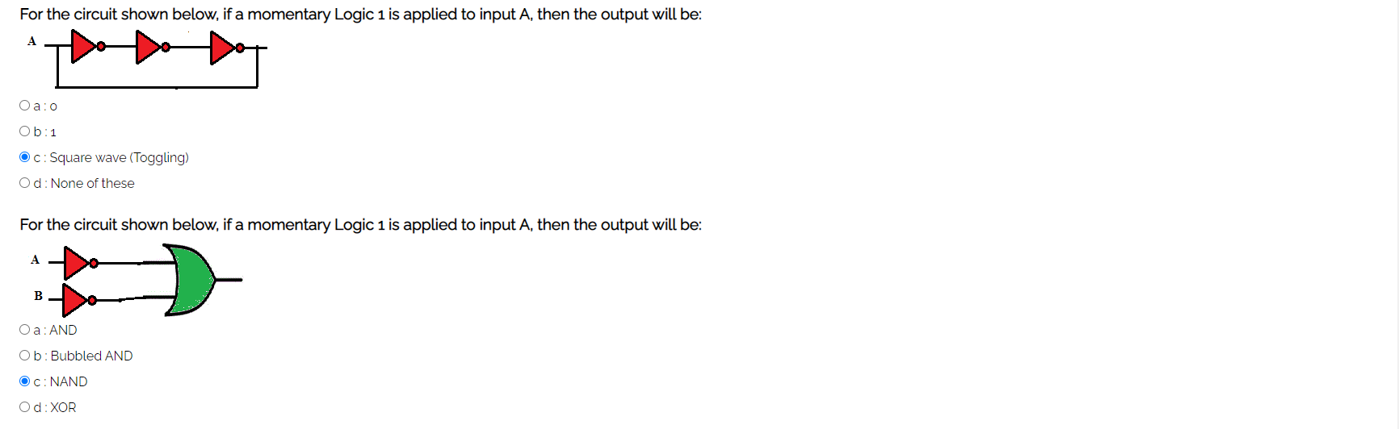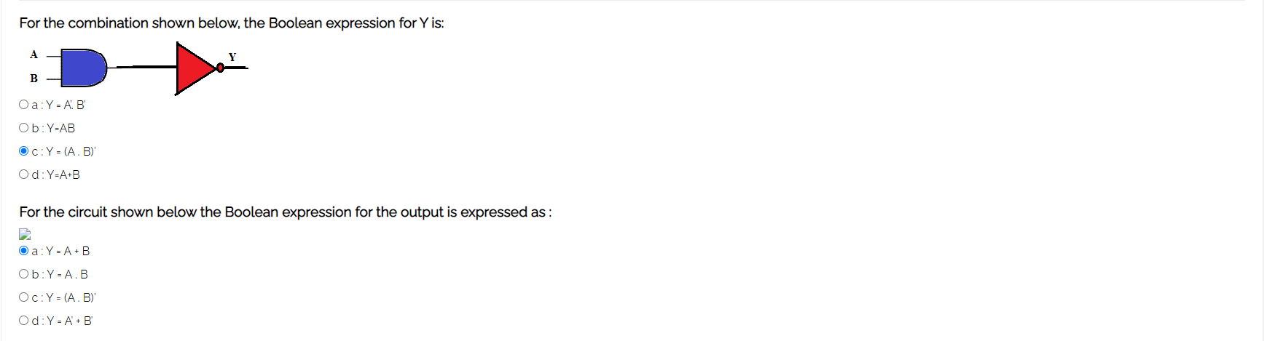**Post-test :-**